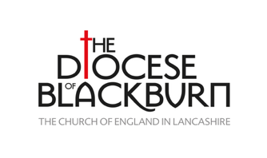
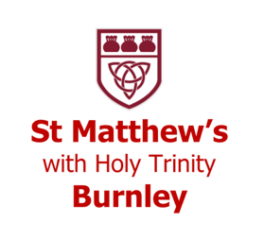
St Matthew’s, Burnley
Community Missioner
Job Pack

Introduction to St Matthew’s Church
We are a thriving liberal catholic church in Southwest Burnley. We are a fully inclusive and diverse church, representing a broad cross-section of cultures, nationalities and traditions.
During the Covid pandemic, and since, God has turned the church from being more inwardly focussed to be more outwardly focussed. Our regularly weekly attendance has risen to above pre-Covid levels. The church building is now open most days and those engaging with church have diversified in age and background. More people have stepped into leadership roles.
As well as worship services our weekly activities include Lunch Club, Toddler Group, Uniformed Organisations, Youth Choir, Parish Prayers, Fun Church (a Messy Church style weekly gathering) and Wednesday Morning Group (a weekly session exploring all areas of the Christian Faith).

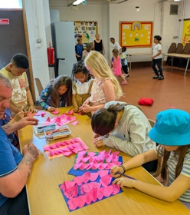
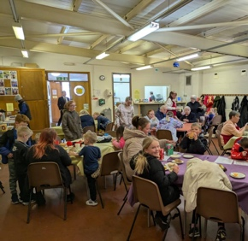
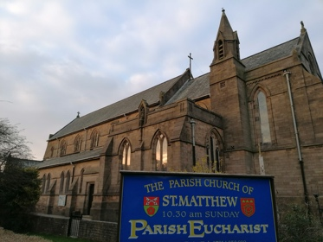
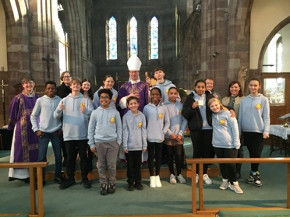
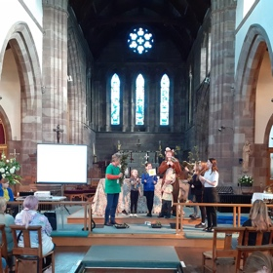

Introduction to the Role
Our parish vision for this role is to grow disciples of Jesus Christ in obedience to the Great Commission (Matthew 28:19). The post holder will live out the Gospel by proclaiming Jesus in word and action.
Five years ago we started a new midweek congregation aimed at families called ‘Fun Church’. Out of this developed a Wednesday morning discipleship group for those new to the Christian faith. More recently our work with teenagers has grown. As we seek to grow our team, we are open to following God’s lead for the next steps.

You’re welcome to make an informal visit to St Matthew’s, the best time to do this would be during Fun Church (3.30pm-5pm on Mondays) or Lunch Club (12.30pm-1.30pm Wednesdays). You can contact the Vicar, Fr Alex Frost, on alexthevicar@yahoo.com.
Job Description
Role | Community Missioner
Accountable to | St Matthew’s Church PCC
Reporting to | The Vicar
Salary | £12,480 per annum
Hours | 16 hours a week  Some working required at the set times of activities other hours can be worked flexibly. Some evening and weekend work may be required.
Place of Work | Home, St Matthew’s Church & St Matthew’s Church Hall  St Matthew’s Church, Harriet Street, Burnley, BB11 4JH
Holiday entitlement | 25 days + 8 bank holidays per annum (pro rata for part time employees)

Purpose of the Role
Are you passionate about seeing people living a life fulfilled as promised by Jesus? We are seeking a committed Christian to build creatively on work done over the last five years to reach out to the local community. The purpose of this role is to grow disciples of Jesus Christ specifically by providing ‘ways in’ to church and faith for people who are new to Christianity or who haven’t recently had a living and active faith. Part of the role will also be building up leadership capacity and skills in others.

Key Responsibilities and Tasks
- In collaboration with church leadership and existing volunteer teams, to evaluate the current provision of Fun Church and Wednesday Morning Group
- By building upon or developing current provision, to prepare and run regular activities for families to explore the Christian faith and oversee a regular discipleship group
- To support people to take the next step in their faith journey and to grow young disciples
- To lead and nurture existing teams of volunteers with tact and diplomacy
- To build confidence in volunteers by empowering and resourcing volunteer leaders
- To prayerfully discern potential new leaders and invite them to get involved
- To ensure safeguarding responsibilities are fulfilled
- To signpost those who attend church activities to local charities, services and the clergy, as appropriate, for support and pastoral care
- To pray with and for people and activities
- To support other areas of ministry within the church by sharing resources and bringing creative ideas to the table
- To be a presence at church-run activities e.g. Lunch Club or Toddler Group to build positive relationships
- To seek and apply for relevant grants
- To communicate about activities both inwardly (to the PCC and by providing and annual report for the APCM) and outwardly (online and via posters etc.)

Quotes from church members and volunteers
I started coming to groups at church as I was in a bad place with my mental health. Church felt like a safe and non-judgemental place and was somewhere I could go and not feel uncomfortable.
I come to Wednesday morning group because it’s a way to explore my faith with others that share similar values … Lunch club helped me to get on my feet, and become debt free, now I can give back to others.
Before attending St Matthew’s I was in a state of loneliness and desperation for belonging. I was invited to attend the Wednesday group and I’ve never felt such openness and welcoming from the group and the church. I enjoy learning more about Jesus and having a supportive community both personally and religiously.

Training
The post holder must complete Safeguarding training and other necessary training as the role requires e.g. First Aid training. Training opportunities for development in Lay Ministry will be available from The Diocese of Blackburn. Support and mentoring will also be provided by the Diocese of Blackburn’s Urban Ministry Enabler.

Support
The post holder will be working with and alongside the Vicar, retired clergy, authorised lay ministers and a hard-working PCC. They and their ministry will be supported in prayer. A full induction programme will be offered to the successful candidate.
Person Specification
Criteria | Essential/ Desirable | Assessed by:  Application/ Interview
A passionate and committed Christian  Given the nature and context of the work it is an occupational requirement that the post holder should be a communicant member of the Church of England or a full member of a church within Churches Together in Britain and Ireland, in order to fulfil the main purpose of the post. This post is therefore exempt under Schedule 9 of the Equality Act 2010. | Essential | Application / Interview
Inclusive Ethos  St Matthew’s Church is a member of the Inclusive Church network (https://www.inclusive-church.org). The post holder must be willing to work positively within this ethos. | Essential | Application / Interview
Good communicator | Essential | Application / Interview
Empathetic & pastoral Heart | Essential | Application / Interview
Heart for Mission | Essential | Application / Interview
Confident in ICT e.g. using Microsoft Word, PowerPoint | Essential | Application
Experience of working with children and families | Essential | Application / Interview
Experience of working with volunteers | Essential | Application / Interview
Experience of leading a team | Essential | Application/ Interview
Able to keep appropriate boundaries and maintain accountability | Essential | Application / Interview
An ability to solve problems | Essential | Application / Interview
Excellent organisational skills | Essential | Application/ Interview
A proactive person with the ability to work using their own initiative | Essential | Application/ Interview
A good understanding of safeguarding and a commitment to following CoE procedures | Essential | Application / Interview

Additional Terms and Conditions
- DBS: Appointment is subject to an enhanced DBS Check
- Probationary Period: 3 months
- Notice Period: 1 month
- Expenses: to be agreed by the PCC
- Right to work: The post-holder must have the right to reside and work in the UK
The Diocese of Blackburn is committed to safeguarding and promoting the welfare of children, young people and vulnerable adults. All post holders and volunteers are expected to share this commitment.

For an informal conversation about this post please get in touch with Fr Alex at alexthevicar@yahoo.com

How to apply:
To apply for this post, please send a completed application form and confidential declaration to stmattsburnley@yahoo.com
Closing date: 24th February 2026

